Lab 1

1. IP address: 192.168.1.102 TCP port number: 1161

2) IP address: 128.119.245.12 TCP port number: 80

3)128.119.245.12 port 50306

4) The sequence number of the segment used to initiate the TCP connection is 0. We can see that the message contains a SYN flag indicating that it is a SYN segment.

5)The sequence number of the SYNACK segment is 0.

The value of the acknowledgement field is 1. That value is determined by the initial sequence number plus one.

The message carries flags that say that it is a SYN ACK message.

6) Sequence number of the TCP segment containing the wanted HTTP Post Command is 149571.

7) minimum window size for the trace is 5840 bytes, which will grow until it reaches the maximum receiver buffer size of 62780 bytes. The sender is never throttled due to lacking the receiver buffer space.

8) Length of each of the first TCP segments is 708 units. The following segments are all 1514 units.

9) Minimum amount of available buffer space is listed at 65535. The sender is not throttled because we never reach full capacity of the window.

10) No segments were retransmitted. Old Acknowledgement numbers were never resent in order to re-request former packets.

11) Receiver seems to be acking approximately 432 bits. There are some cases where the receiver acks every other segment. This is shown when more than one ack occurs in a row.

12) Throughput can be calculated by using the value of the last ack(149,629)- the first sequence number(1) divided by the time since first frame (1.6) = 93517.6 bps.

13) TCP slow start phase begins at just above seq number 5000, and ends just before sequence number 10000. Congestion avoidance takes over at 10000.

14) a) 7) minimum window size for the trace is 5840 bytes, which will grow until it reaches the maximum receiver buffer size of 65536, this means that we are limited by the minimum amount of buffer space

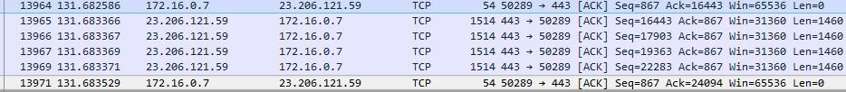

b) 13)The TCP slow start phase begins at around 0, and ends just before sequence number 14000. Congestion avoidance takes over at 14000.

